Parsons, Michael (from Linked In)
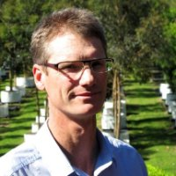

B.Sc. (Forestry) ANU 1987-1990.

Senior Professional GHD 2004 –2007. Provided technical excellence which underpinned development of new services in sustainable forest management and carbon sequestration. Resource Development Manager SFM (Sustainable Forestry Management) Australasia 2007 –2009 . Senior Consultant Jaakko Poyry Consulting 1994 – 2004. Based in Helsinki, Singapore, Canberra and Melbourne offices. General Manager Trees Impact Pty Limited 2012 –2013 Sydney Area. Trees Impact is Australia's only truly specialised supplier of high-impact, semi-mature containerised trees that set the standard for urban forest plantings. Consultant Michael Parsons 2009 – , Sydney Area.

